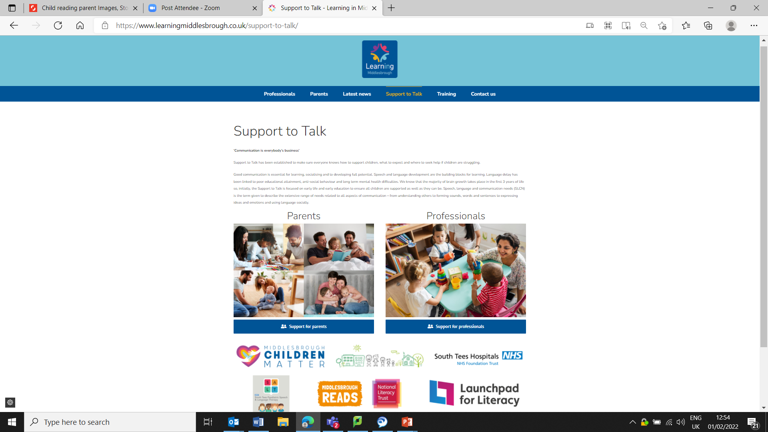
Support to Talk – web resource

Are you worried about how your child is talking?

Do you know what sort of response, communication and speech to expect at different ages?

The Support to Talk website has the milestones, useful videos and suggestions to do at home that might help!


https://www.learningmiddlesbrough.co.uk/support-to-talk/

‘Communication is everybody’s business’
Support to Talk has been established to make sure everyone knows how to support children, what to expect and where to seek help if children are struggling.
Good communication is essential for learning, socialising and to developing full potential.
Speech and language development are the building blocks for learning. Language delay has been linked to poor educational attainment, anti-social behaviour and long term mental health difficulties.
We know that the majority of brain growth takes place in the first 3 years of life so, initially, the Support to Talk is focused on early life and early education to ensure all children are supported as well as they can be.
Speech, language and communication needs (SLCN) is the term given to describe the extensive range of needs related to all aspects of communication – from understanding others to forming sounds, words and sentences to expressing ideas and emotions and using language socially.

